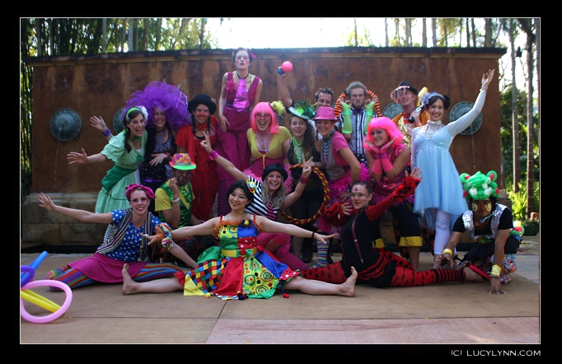

Spark! is an international volunteer circus organization that teaches playshops, performs spectacular fire shows, and donates toys, tools and art supplies to disadvantaged children along the Northern Thai-Burmese border.

Over 200,000 refugees line the borders of Thailand and Burma, held in refugee camps that can barely manage to provide for basic necessities. Tens of thousands of these refugees are children - children who have been traumatized by the ongoing war waged by the illegal Burmese military dictatorship against the regions hill-tribes. The refugee children flee from Burma, sometimes orphaned and alone, sometimes with their families, into the relative safety of Thailand. Here they end up in the camps, or living illegally along the border regions, at huge risk of being taken into the sex trade, suffering malnourishment and ongoing threats to their well being and lives. Various NGO's work with these children creating orphanages, providing some basic services like shelter, clothes, food and where possible, even education. But children have needs beyond the "basics". Children need hope, joy and play.

In 1989 the UN declared the right to play as one of the basic rights of children. The United Nations Convention on the Rights of the Child, Article 31 recognizes "the right of the child to rest and leisure, to engage in play and recreational activities appropriate to the age of the child and to participate freely in cultural life and the arts."

At SPARK! we approach this as an international challenge to make this declaration reality! We are a group of 20 spectacular international volunteer circus performers who have come together for the last five years to bring joy and play to these groups of disadvantaged children. When we visit schools, part of our group is composed of Thai and ethnic Burmese hill-tribe teachers who share their experiences with their own communities to help create positive change. We reach over 4,000 children each year as we go into the local villages, refugee camps and hidden migrant schools in the remote border regions of Thailand to perform a circus-style fire show, teach playshops (poi, hula hoop, staff, juggling, acrobatics, breakdance and more!) and offer donations of toys, art supplies, and tools. In addition to all the fun that the children have learning circus skills, this project is designed to develop their creativity, physical fitness, communication skills, teamwork, confidence and cultural awareness. Play is a fundamental part of children’s development and we bring a big spark of happiness, love, amusement and entertainment into these children's lives and the lives of those who work in the camps and orphanages. Every year, we travel to them to lighten their days and to bring them some magic.

Spark! Circus 2014

Jan 7th-19th-teambuilding, fundraising performances

Jan20th^{st}- Feb 24th- playshops, performances and toy donations to disadvantaged children in the Mae Sot region of Thailand, along the Thai Burmese Border.

Fun- d-raising Section
Participants: Nola, Andrea, Howard, Josh, Grimm, Julia, Quinn, Kat, Rachel, Cody, Miri, Ali, Francine, Morten, Eric, Serphen,Sara,Louisa,Charlie, Shelley and Jexi
The objectives of this team and time period were:
1)- fundraising-shows to raise funds for the project through ticket sales, hatting, auctions, raffles
2)–raise awareness-creating awareness of the desperate and difficult situation of refugee and migrant children long the Thai Burmese border
3)-create group performances/team building- choreograph and put together group routines. Begin to get into a flow of what tasks need to be done, how to do them, and to start working together functionally as a group.

Meeting the Objectives:
We did a total of four fundraising shows this year, two on Ko Phan Gan, and two on Samui, Objectives were all met, some to an extraordinarily wonderful degree! The fundraising show and auction at Sanctuary resort exceeded our wildest expectations, as did the larger show at Bandara. We raised almost one third of our overall budget through these shows! Once again, Spark alumni Shelley Poplak, did an absolutely fabulous job organizing the biggest and brightest Spark event to date!
Educationally, we had the opportunity to show our video, and hand out brochures /cards. We had past performers do talks about their Spark experiences and give a taste of our day show and activities we do up north. It was well received by all!
The time spent team building and choreography is invaluable. The team also requires and appreciates the time to adjust to a new country and climate, make cultural adaptations, get to know each other, and train hard together before the real work with the kids begins!
The main challenge of this section of the project was the location. In order to be near the tourist resorts, we are also near bars and restaurants and a noisy party atmosphere that can make disciplined training difficult for the team. Travel between islands is also challenging for a large performance group with gear. We hope to address that by doing the training for the next project at a quieter central location, and only come into the resorts for the actual shows.

Play Project Section
Participants: Andrea (CAN) Julia (QUE) Kat (CAN) Quinn (CAN) Howard (UK) Grimm (BEL) Morten (DEN/AUS) Eric (SWE) Linnea (SWE) Sara ( IRL/THAI) Miri (PRT/DEU ) Rachel (US) Cody (US) Josh(US) Louisa (UK) Madeleine (US) Charlie (UK/France) James( IRL/DEU) Jexi (US)

Arrival in Mae Sot and prep work

The team arrived and moved smoothly into their accommodations. The team organizers began outlining the established structures and systems used for day shows, night shows, playshops and group games, and assigning roles. We renewed contacts in the community, and brought key local people in to do presentations, sharing their cultural and refugee experiences so the team could better understand the socio political situations of the communities we work with.

On To the Children—
We once again worked closely with local organizations such as Help Without Frontiers. Coloboria Birmania, Project Heartworks, and Borderline Collective. We have much more overall efficiency as a partnership, with a local contacts to guide us and generally facilitate our access to the refugee and migrant communities. We are grateful for their assistance!
This year was exceptional in the new opportunities opening up within Burma itself. The border is opening. There was far greater access to the IDP camp schools and villages (internally displaced refugees) and also to the Burmese towns, who invited us specifically and hosted us like royalty! For the first time we spent several days within Burma, and at Karen villages in Karen State.
Almost every day we went to at least one school, clinic or orphanage, sometimes splitting into two groups so we could reach more kids! We would perform a morning show, followed by playshops and group games, then take a break in the heat of the afternoon and return to do a fire show in the evening for the entire community! We were thrilled that at almost every location the arrival of the circus became a cultural creative exchange, with the locals and school kids also performing and doing shows for us! The mutual participation aspect was great, empowering for all. It was beautiful to see their traditional arts and dance, and to have them share their skills with us.

Nu Poe Refugee Camp

Each year this is the highlight of our trip. We are honored to be invited to stay in the camp, get to know the refugees and see directly how life in a refugee camp works. We had a great social exchange night with some adult English speaking students from one of the schools, sharing emotional and funny stories and experiences and answering questions. Another night we did a fire and aerial show for over 4,000 people! The community there makes it clear they look forward to seeing us every year. Right now there is a lot of instability in the refugee camps, so a visit next year is uncertain, as there is talk of closing down the refugee camps altogether as the situation in Burma opens up. Already the population was greatly reduced. It is creating a lot of stress for the remaining refugees—all the more reason to lighten their days with play! We hope to see them again…

Bla Toe , Mo Chee, and Mae Kong Ki villages

These are villages in Karin State, Burma. We travelled some crazy dusty roads through the jungle to get to these remote locations! It was exceptional visit true old style Karin villages, that have remained largely culturally untouched. We stayed with the villagers where they played us music, taught us jungle medicines, and traditional skills. Then we performed for them—so exciting for all--they had never seen anything like it!

The aerial acrobatic show, having women dancing while suspended on a huge metal pyramid in the sky, literally took their breath away! People were gasping, squealing, exclaiming at the pure amazement of it all. At the end of our stay there none of us ever wanted to leave, and all promised to do our best to return… The children there are desperately poor in some ways, but have a solid simple village life that is rich culturally. They so full of love and enthusiasm for play, curious and good learners!

Overview: Meeting Spark!Circus Objectives

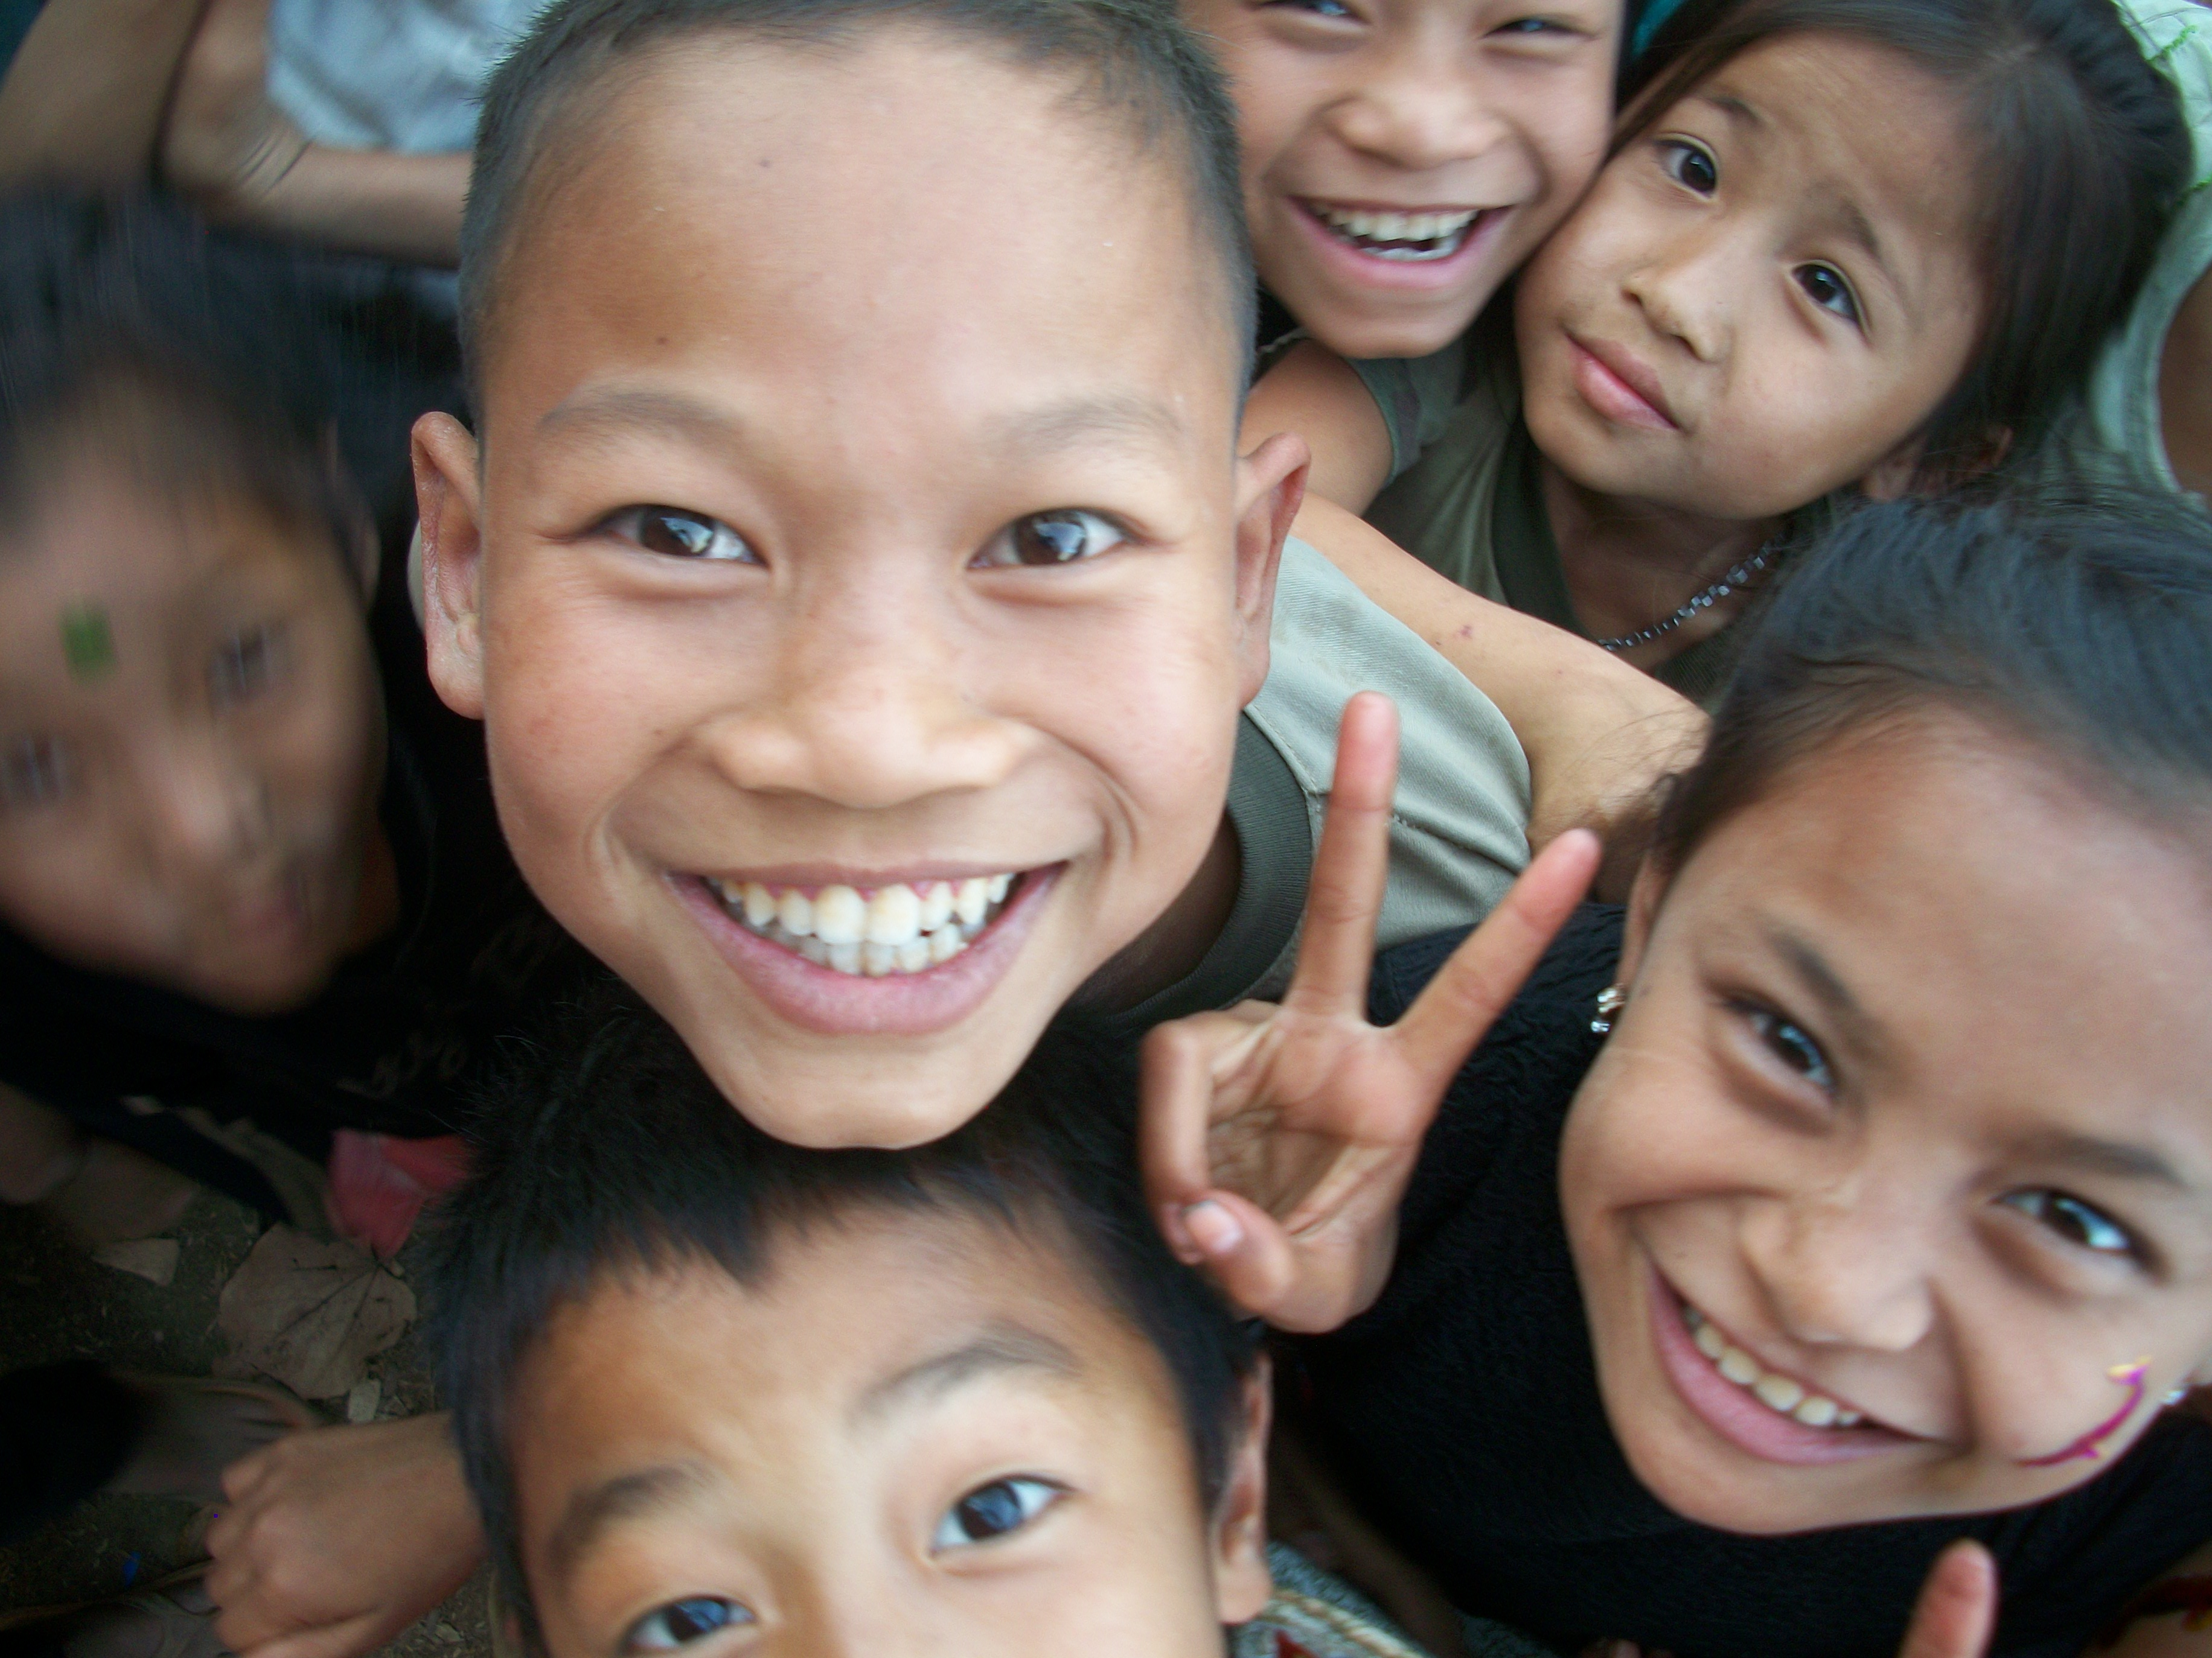

SMILES
The primary goal of the Spark volunteer circus mission is simple, to make children smile! And in that, we meet our objectives in an extraordinary fashion… We reached well over 7,000 children this year! We gave them all an opportunity to PLAY! and donated an absolute BOUNTY of toys, art supplies, costumes, instruments and circus props , so that the smiles , creativity and fun will continue on long after we are gone.

Playshops
As always, the skill set of the team was superb. They showed obvious care and commitment to their work with the children. The teachers and performers all brought an astounding range of fun play activities and games, all of it filled with attentive love, and joy! All the usual favorites of our circus were taught: poi, diabolo, staff, hoop, slack line, devil sticks, dance and juggling. A new aspect for this year was a workshop in African style dance with live drumming. The kids enjoyed this workshop most of all, dancing for hours and hours with great enthusiasm, drumming on anything they could get their hands on, always coming back for more!
We see the children build on their skills from year to year. Some are becoming quite good circus performers! The children are also gaining in confidence, creativity and openness. It is much easier to get them involved in our activities now then it was when the project started many years ago. Now, they leap right in willing to try new things and old, show and share.
Performance
The team put together amazing routines for both day and night. The day shows are fun, full of laughter and play. The fire show at night is bold and dramatic, mystical and inspiring. This year we had a new element added to both shows—Aerial Acrobatics!

NEW THIS YEAR!! AN AERIAL RIG!
We are the only circus group in Thailand to ever travel remote regions with a portable aerial rig! It was a major challenge to get this apparatus shipped to Thailand, but so very worth it. The audiences had never, ever seen anything like silks, lyra, and trapeze. They were absolutely awed. The aerial shows and acts were by far the most popular, and when we mixed them with fire, I thought the kids might just explode from pure excitement! It was utterly fantastic.
The primary challenge of fire and aerial circus shows is of course safety. We had some clear protocols in place around this to prevent injury. The performers were completely professional and responsible in their careful approach to set up, show and break down, so we had no safety issues at all. The aerial rig was costly to purchase and get to Thailand, but once there proved to be a great addition to our repertoire. It was very reasonably portable with a short set up time and huge performance impact.

Donations
The donation kits were better than ever! We gave away a brilliant supply of locally made poi, staff, devils sticks, juggling balls, spinning plates, diabolo, hula hoops, and more. We taped over 600 hoops ourselves! We purchased slack line for rope walking/balancing, juggling flags, and yoga mats for acro-balance, little costume supplies like small hats and glitter and sparkly hair accessories), items for school like books, pens, pencils, paper, stickers, and art supplies like paints, modeling clay , crayons, erasers, paper etc.
At the refugee camp we also donated blankets, fleecy sweater jackets, sarongs, and socks, and bed mattresses because it was very cold there. 2014 was the coldest season in over 30 years, deadly for the unprepared.We also donated our two sound systems to schools and social projects. Our mini laptop computers went to a school training kids in computer repair. We also made substantial donations of practical needs funds to various organizations working with our kids-- helping to make sure their basic needs are also met.

Bonus FUN
-Facepainting remained the most popular play station of all, and this year we had a new great assortment of safe, non-toxic colours and glitter!
-We printed 100 of colorful Spark! Circus T Shirts, and gave them out to all our supporters: teachers we work with, officials who make our access possible, generous donors, and of course, the team members!
-We also did our own informal “carbon taxing” as a form of environmental awareness and respect. We burn a lot of fuel for our shows, and for our transportation—so to help compensate we planted at least one plant/tree for every show we did!

TEAM Secondary Objectives:
Secondary objectives are mostly pertaining to the team experience, and what we carry back out into the world after the project. As a volunteer team, we aim to have a safe, fun, and educational cross- cultural experience while working playfully, cooperatively, and effectively to help support a disadvantaged area of the world.
All of us find it to be a life changing, unforgettable experience. We learn about ourselves and other cultures, about how to work together under adverse conditions, to culturally adapt /compromise, improvise, and how to genuinely smile, even when exhausted or in pain. We learn how to draw a smile out of a reluctant scared child, how to encourage someone with no self esteem (both on our team and amongst the kids) and how to function as a tight, professional unit. We learn to look directly at suffering, right through it, to the heart, and find out how to create happiness, even there. We did all this, and did it well. These are experiences that will be valuable applied in all areas of our lives.

Cross cultural communication
There are always challenges in gathering and coordinating an international team, Languages, and cultures collide in a variety of interesting and exciting ways, particularly amongst eclectic circus performers! There were a few tense moments amongst the team, usually due either to cultural misunderstandings, exhaustion, or inexperience, but all were worked through successfully.
We are very pleased to note that due to our commitment to happiness, lack of religious or political agenda and respectful reliability, our reputation within the community is solid, which enables us to do many things foreigners usually can not.

Health and Safety
We have an incredible safety record as a circus— once again, not one injury amongst thousands and thousands of rambunctious kids!
The team also did well with their personal safety. Only a few minor burns, which is a common and accepted part of daily fire performance.
However, there remains concern about the level of illness the team experiences overall while on this project. We had several issues with dysentery, seriously infected bites, heat exhaustion and chest infections… We have taken many steps over the years to prevent illness, but it seems that regardless, exposure to new bacteria, travelling and working hard in a foreign environment, means that some people will get sick. We did ensure that everyone got prompt and excellent medical care when needed, and that all participants were fully insured.

Leadership Team Structure
This year we planned for a volunteer organizing team of three people, with myself, as paid project coordinator. Unfortunately, due to unforeseen circumstances and family emergencies two of the team leaders were unable to come to Thailand for the actual project, though they worked hard on preparations from their home countries! We filled their positions on the ground from other experienced team members, which worked out well after the initial adjustment and learning curve. The volunteer team leaders received small honorariums and some funds towards flight expenses and accommodations.
Future Directions
New Territory- The situation on the Thai Burmese border is changing radically as Burma becomes more stable. Many refugees are choosing to return to Burma. Others are in a stressful limbo, with the threat of refugee camps closing down, but no place for them to go (they were born in the refugee camps, have no familiarity or connections left in Burma). But overall, the well being of the children in this area has been significantly improved over the years. Though we love this community very much, and would miss them terribly, it is time to consider running the project in other regions where the need is greater. We are thinking to run one last project out of Mae Sot in 2016, focusing on teaching teachers, so the circus energy will live on there without us returning year to year.
We are currently discussing the possibility of running a project on the Syrian border, in 2015, in Turkish and Lebanese refugee camps, possibly working collaboratively with three other international circus organizations, (Clowns Without Borders, Afgan Mobile Mini Circus, and Rickshaw Circus.) This will be challenging, but a great opportunity to learn from each other and different approaches to circus and social development projects worldwide.
We are also researching the possibility of doing a project with some communities of the First Nations people in Northern Canada. We will be reaching out to those isolated and disadvantaged communities to assess interest and need, determine what kind of program is best for their communities, find out who we can work with locally, and sourcing funding for the program.
Team size—We have been working with very large teams of around 20 people. We are interested in tightening up the structure of our project to have a smaller, more experienced team, perhaps in paid positions instead of fully volunteer. We think this will enable easier travel, less time on team issues and training, and more energy for the kids!
Staff_-We want some! For future projects we will be creating paid part time, year long positions for the team organizers so they will be able to fully dedicate their time and energy to the circus project. The work -load and responsibilities for those in these positions is significant. Their roles are essential to the smooth functioning our NGO. And we want to attract people with the professional social circus experience we need to be effective in what we do. My own role as director of Spark will be minimized in the on the ground projects. I will focus on management, overseeing and developing the long term vision. I am very excited about the potential for growth this change offers Spark Circus! With dedicated energy time and resources, there are many new directions to explore.

Conclusion
Spark Circus created so much JOY for the kids over the years! Though there is room to grow, we can certainly consider our project a success. We gathered an amazing, inspiring international volunteer circus team, fundraised effectively, played , taught and performed professionally, reached out to thousands of disadvantaged children and their communities, successfully increased awareness of the issues creating their vulnerability, and ultimately, brought smiles everywhere we went, leaving happy memories and gazillions of toys! Success!
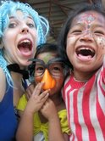
The generous contributions of people from all over the world, along with the time, money, energy and efforts of all our volunteers, have made Spark Circus and all that we do possible. Nothing like this could have ever been achieved alone. I hope that when you look at the smiles of these children, it brings a smile to your face too! What started as a small spark of joy, has become a roaring fire of happiness.

Thank you!
Sincerely,
Andrea Russell
Project coordinator, Spark! Circus www.sparkcircus.com

